**How-to Install Webmin on a Raspberry Pi (updated)**

Posted on [**16/07/2016**](http://www.ramoonus.nl/2016/07/16/install-webmin-raspberry-pi-updated/)

This post will tell you how to install Webmin,a web-based interface for system administration for Unix (including  Raspbian).

This post is an update of [*How-to Install Webmin on a Raspberry Pi*](http://www.ramoonus.nl/2013/10/20/install-webmin-raspberry-pi/)

Run the following commands in the terminal. You need superuser (root) access.

**Dependencies**

apt-get install perl libnet-ssleay-perl openssl libauthen-pam-perl libpam-runtime libio-pty-perl apt-show-versions python

**Installation**

wget http://prdownloads.sourceforge.net/webadmin/webmin_1.801_all.deb

dpkg --install webmin_1.801_all.deb

rm webmin_1.801_all.deb

**Automatic updates**

cd /root

wget http://www.webmin.com/jcameron-key.asc

apt-key add jcameron-key.asc

Edit the /etc/apt/sources.list file on your system and add the following line:

deb http://download.webmin.com/download/repository sarge contrib

How to install webmin using tar.gz file

To download the Webmin tar.gz package, either follow the link on the [downloads page](http://www.webmin.com/download.html) , or run commands like :[root@yourhost /]# cd /tmp

[root@yourhost /tmp]# wget <http://prdownloads.sourceforge.net/webadmin/webmin-1.840.tar.gz>

When unpacked, the distribution creates a subdirectory called webmin-1.840 under the current directory. Since recent versions of Webmin support installation into a directory of your choice, you can pick a destination directory such as /usr/local/webmin. Then run the following commands in the directory containing the webmin-1.840.tar.gz

[root@yourhost /tmp]# tar -zxvf webmin-1.840.tar.gz

[root@yourhost /tmp]# cd webmin-1.840

[root@yourhost /tmp/webmin-1.840]# ./setup.sh /usr/local/webmin

------------------------------------------------------------------------------------------------------------

Twitter interfacing with python and Raspberry pi

Pip install python-twitter

Pip uninistall twitter

Installing Dependencies

INSTALL PYENV DEPENDENCIES

sudo apt-get install -y make build-essential libssl-dev zlib1g-dev libbz2-dev libreadline-dev libsqlite3-dev wget curl llvm git

DOWNLOAD AND INSTALL PYENV

curl -L https://raw.githubusercontent.com/yyuu/pyenv-installer/master/bin/pyenv-installer | bash

YOU WILL SEE THIS MESSAGE

Interfacing 18b20 with raspberry pi

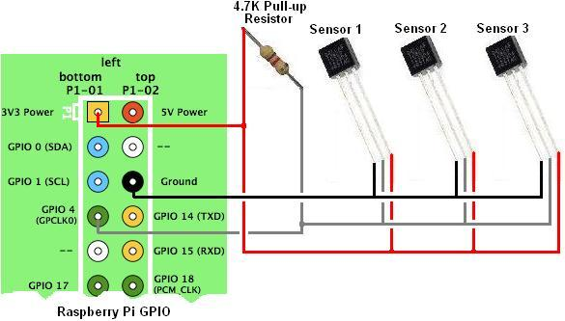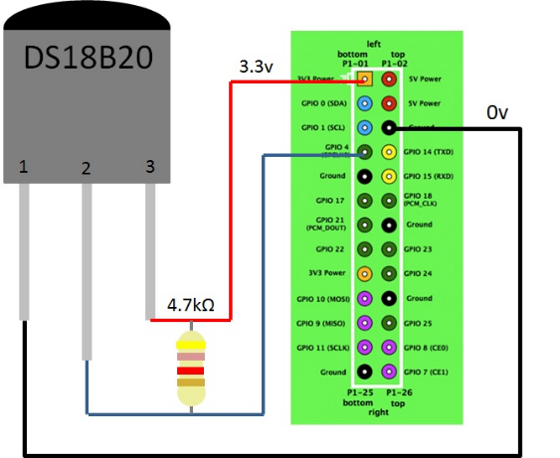

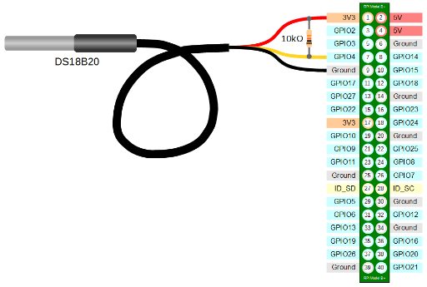

Library for ds18b20

[**https://github.com/NetmaxIOT/w1thermsensor**](https://github.com/NetmaxIOT/w1thermsensor)

**Also install**

**Usage as CLI tool**

**The w1thermsensor module can be used as CLI tool since version 0.3.0.**

***Please note that the CLI tool will only get installed with the Raspbian Python 3 package* (sudo apt-get install python3-w1thermsensor)**

**Program for reading ds18b20**

**First run cli to get sesor id**

**w1thermsensor ls**

**Then write program**